The Dark Times Glasgow Edition
03/2022 Vox Populi Vox Dei
An announcement from the Justicars of the Clans:
The Ravnos have agreed to act as adjudicators of the Grand Tournament being held by our Esteemed Elders. Going forward we will expect Princes to help us to build bridges with the Ravnos. While our cousins to the east are the only clan who will be able to carry out the coming tasks, they have sworn to protect the Masquerade and no Kindred will meet destruction at their hands while undertaking this task. If there are any issues with this, we will be on hand to deal with the matter.
We are intrigued to see what our cousins are able to achieve.

Our Esteemed Elders are offering something near unheard of. A Domain Boon. A boon that will allow the successful domain to host an event with their presence at which point they will bestow a gift to the domain of the domain's chosen. Do you wish to have a new library? Do you want to build a new Elysium? More resources to protect and maintain the Masquerade? Any tool or resource that benefits your full domain. The possibilities are endless and the status alone could save even the most infamous domains from the bottom rungs of society.

Come, compete and build bridges. Take the chance to be a part of the greatest political attempt of this century.
From the desk of Justicar Xavier

Announcements from last month:

Laws of the Domain of Glasgow
Rule 7) Ghouls
Kindred are free to create Ghouls as they see fit, but are responsible for their actions. Should a Ghoul be caught in breach of the traditions, they will be killed and their domitor shall be held accountable.

Elysium sites
The official sites of Elysium and their current status within the Domain of Glasgow are:
Gallery of Modern Art – Active; Bardowie Castle - Active
Kelvingrove Museum and Art Gallery - Inactive until further notice
The Peoples Palace and Winter Gardens has been retired as an Elysium

Adverts

Lost? Need guidance? Unsure of what your future holds?
Worry no longer, for Soteria's Index Prophetica is now up and running. Friends to Soteria may avail themselves of the wisdom and guidance of numerous sources, all within our regularly updated, easy to navigate database.
Clarity

TALENT WANTED
For a wondrous talent contest of entertainment and wonder
Any and all performances and acts considered
For details contact Felicity the Clown

Harpies Business
Edinburgh: Farr – It seems that some cities can only catch the eyes of the riff raff.
Aberdeen: Douglas Dougal – Thank god for the Gangrel and their sense of taste.
Inverness: David Griene – I guess the answer was no….
London: Duke Benedict – How tiresome to see my fellow harpies stoop so low.
Severn: Benedict & Algernon – oh boy do the fat cats know how to put on a show or what.
Manchester: Lucretia – Does anyone even bother to read this?
Birmingham: Bethany Trimble – Malkavians roaming, be on the watch.
York: Anne Jacques – Oh… what do you know, it is Glasgow.
Norfolk: Carl – Ramblings make life interesting and eventually everyone stops paying attention.
Carlisle: Samuel McAlpine – I’m sorry a paper what?
Derry: Hilda Berry – smirk.
Paris: Viola Du Bois – It is always amusing to watch the blue bloods infight. No matter what I do or become I will always be French.
Soteria: Wrath - "A message to the Fae's Whore: When you left us, there were no hard feelings, but then we find the shit sandwich you left for us. Did you think you can try and provoke us into war? You are more delusional than I thought. Good fucking riddance."
Others (Glasgow): No submission

Update from the Scourge
Probation : None
Newly accepted: Ashe Ward
I'd like to thank all the visitors to Glasgow for the treasure hunt for their cooperation and respect for the city and I wish you the best luck in following up on the rest of the clues. Thanks also to the organisers for working with us to make the process smooth and convenient for the treasure hunters.
Jack
Scourge

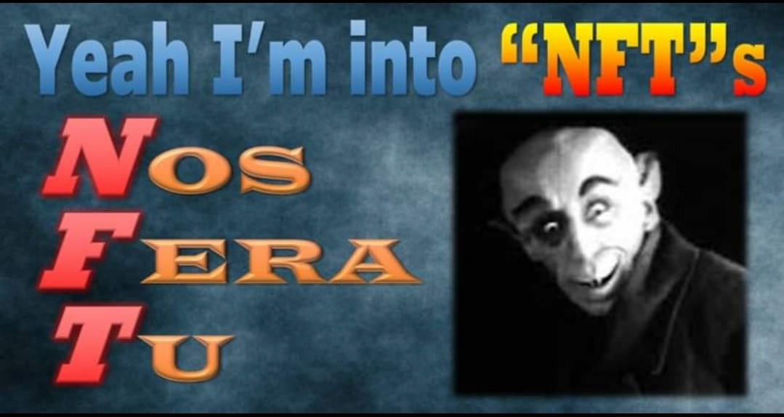

For one and all

By Elder Victor "Bastard Son" Crane, Deputy Scourge, Gangrel Primogen of Glasgow, Ambassador of Helsinki, Serverie

You might not have wings, but we're still birds of a feather. We hunt at night, but the prey be different. We snarl, we bite, fight fang over claw, separate reasons, but the massacred don’t know the difference.
We roar at the same black sky, roam through trees that look the same. we are wolves, the differences don't fucking matter. We are pack. One howl is all it takes to come together. Remember this.

"It matters not how strait the gate" – Henley

It is easy in periods of quiet to lose focus, to lick the wounds and prepare for the next sortie or campaign. Instead of looking or preparing for the next battle or war, one should see the opportunity for growth. Not in viscous conquest in a zero-sum game but sustainable endeavours upon a solid foundation.

We can all benefit from self-reflection and understanding of our strengths and failings. Enduring is not enough. Whilst bloody and unbowed we may see as victory, what good does it do if no one remembers even your name.
Consider not only what you destroy, but what you create in your wake. Mastery or arms and valour in battle may be tenets one holds in high esteem, but they are nothing without honour.
We might all benefit from taking stock and a hard look at ourselves, but I appreciate this will be more difficult for some than others.

- Mr Gordoun overheard in conversation at Elysia

AN ANNOUNCEMENT FROM THE BRAHMIN OF THE EAST
YOUR FIRST CLUE: UK

1.
I used to be a tree Until I traded my roots for routes
I have a rose but no garden

2.
Learners grace my guilded halls
Lord Kelvin, Smith I’ve guided all
Who came to see encased in glass
A fragile memory, a tale long past.

3.
Even a muppet can recite my tale
Follow your feet do not sail
My author sat here watching leaves turn
Across stormy skies in 1881.

Successful Kindred:
Maria O’donnell
Darren Rob
Sir Charles Douglas
Hilda Berry
Congratulations: We offer you hospitality.

The all new out of character section
General knowledge:

There was a strange "apocalyptic sounding bang" that reverberated across parts of Glasgow - google it

Many of the courts are adjusting to the changes in regulations and masquerades are being up held with tighter measures than ever.

The Ravnos have retreated and become scarce again as normal.

Rumours:

The Ventrue are shaken by recent accusations and in fighting.

The Toreador are watching Glasgow closely as the Toreador elder Hugh Jackson and Mary raise the standards.

The Malkavians are fairly quiet and occupied with Soterian upkeep

No tremere rumours

The Brujah approval of Prince Esteban is high

The Nos have their eyes on Glasgow as the clan influence grows

The Gangrel are deeply unhappy that the Ravnos have been given free reign to travel the courts of the UK.

ST Announcements:

The bank account application is currently under review
We have successfully completed the handover of the physical props and funds of the game. We have purchased a cash box and duplicate book to keep a track of funds.
We have made some progress with rules calls:

Rituals will take 1 order point month per ritual level to learn.

A document containing all the evidence of Ewan's investigation will be published, we acknowledge that the timing of the announcement was not ideal and that the situation could have been better handled so we would like to formally and sincerely apologise to players who were upset by this.
We would also ask players for a bit of compassion for us as STs. This is a stressful position to hold, with no benefits to us. We took this on knowing it would be difficult but this does not mean that we should be treated like enemies or with less than the common decency you'd afford to any co worker. This is a give and take situation where we ask you to trust us and give us a little benefit of the doubt that we are not purposefully trying to upset anyone but instead find a way out of the mire the game is in. Both in terms of a lack of process and a lack of information in general. We are essentially building from the ground up here and we cannot do that without some things needing to be changed. This will not always make everyone happy but fairness is our goal so that we can all start off on an even footing and let go of the resentment that has been built among different players who were subjected to questionable actions in the past. Please rest assured that we do not make any decision lightly, even if it is sometimes the wrong decision. *Insert profuse apologies from Ewan*

On this point, Orders took roughly 4 nights of research before we could set pen to paper due to the number of vague rules and lack of mechanics for previous ST calls. We have made a plan to prevent such a late delivery occurring again. But please be aware that real life does happen.

Also while Adam has chosen to take a step back as PL, Michael Scott is still PL and we would like to invite another person to stand or if the previous PLs would like to be reconsidered please let us know.

So I do hope that we can take a bit of time to just enjoy the game tonight and start afresh.

