May 2022 | The Dark Times  Vox Populi |  |  |  |  |  |  |  | Enjoy then destroy
Welcome to  The Court of Glasgow  The latest updates  __  Current Prince:  Prince Esteban of Clan Brujah  __  Current Court Officers:  Scourge: Jack  Sherrif: Sir Charles Douglas  Keeper of Elysium: Mary Graham  Keeper of the Masquerade: Grey  __  Harpy: Unknown  This publication is sent to you via encrypted pathways, but we would ask that you delete upon reading to maintain the masquerade. If you are unsure how to do so, please contact the Keeper of the Masquerade. |  |  |  | 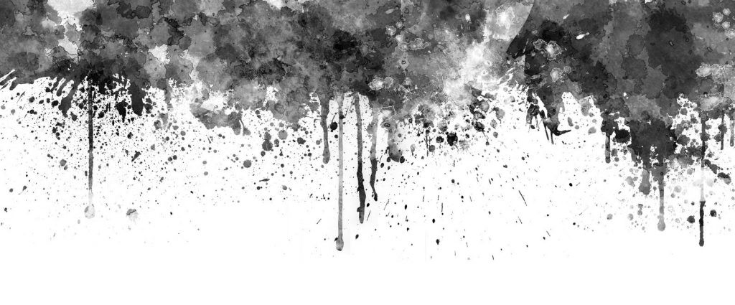  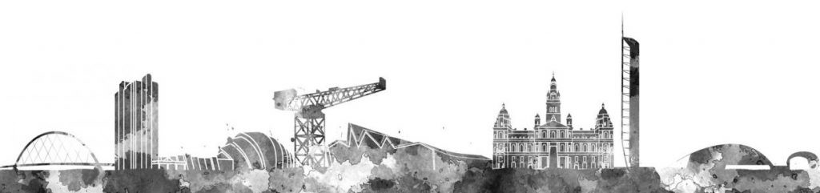
 |  |  |  | Please present yourself to a court official should you wish to see the Prince. If you have not yet been introduced at court, then failure to present yourself to the Prince will be considered a breach of hospitality.
From the Desk of the Prince:

Domain Announcements
Decrees and Commands
 |  |  |  | Video provides a powerful way to help you prove your point. When you click Online Video, you can paste in the embed code for the video you want to add. You can also type a keyword to search online for the video that best fits your document.  To make your document look professionally produced, Word provides header, footer, cover page, and text box designs that complement each other. For example, you can add a matching cover page, header, and sidebar.  Save time in Word with new buttons that show up where you need them. To change the way a picture fits in your document, click it and a button for layout options appears next to it. When you work on a table, click where you want to add a row or a column, and then click the plus sign. |  |  |  | Elysium sites  The official sites of Elysium and their current status within the Domain of Glasgow are:  Gallery of Modern Art – Active; Bardowie Castle - Active  Kelvingrove Museum and Art Gallery - Inactive until further notice  The Peoples Palace and Winter Gardens has been retired as an Elysium
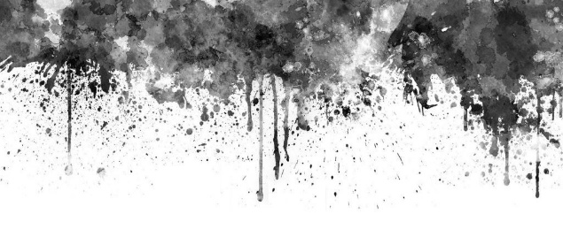Officer Announcements:
Harpy of Glasgow  The latest updates |  |  | Harpy of Edinburgh  Farr |  |  |  | Harpy of London  The latest updates
Unknown |  |  | A prince’s warm welcome |  |  |  | Mirjam Nilsson
 |  |  | Glasgow never fails to delight and amuse.  Till next time. |  |  |  | To make your document look professionally produced, Word provides header, footer, cover page, and text box designs that complement each other.  Page XX
 |  |  |  |  | Page 1

May 2022 | The Dark Times |  |  |  |  |  | Enjoy then destroy
Mirjam Nilsson

The latest breaking news of the day
The latest updates to get you through the day
Save time in Word with new buttons that show up where you need them. To change the way a picture fits in your document, click it and a button for layout options appears next to it. When you work on a table, click where you want to add a row or a column, and then click the plus sign.  Reading is easier, too, in the new Reading view. You can collapse parts of the document and focus on the text you want. If you need to stop reading before you reach the end, Word remembers where you left off - even on another device.  Themes and styles also help keep your document co-ordinated. When you click Design and choose a new Theme, the pictures, charts, and SmartArt graphics change to match your new theme. When you apply styles, your headings change to match the new theme. |  |  | Video provides a powerful way to help you prove your point. When you click Online Video, you can paste in the embed code for the video you want to add. You can also type a keyword to search online for the video that best fits your document.  To make your document look professionally produced, Word provides header, footer, cover page, and text box designs that complement each other. For example, you can add a matching cover page, header, and sidebar.  Save time in Word with new buttons that show up where you need them. To change the way a picture fits in your document, click it and a button for layout options appears next to it. When you work on a table, click where you want to add a row or a column, and then click the plus sign. |  |  | Themes and styles also help keep your document co-ordinated. When you click Design and choose a new Theme, the pictures, charts, and SmartArt graphics change to match your new theme. When you apply styles, your headings change to match the new theme.  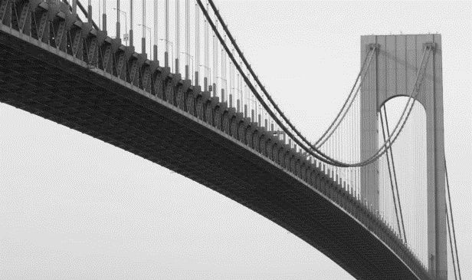
 |  |  |  |  |  | Picture caption: Picture Caption: To make your document look professionally produced, Word provides header, footer, cover page, and text box designs that complement each other.
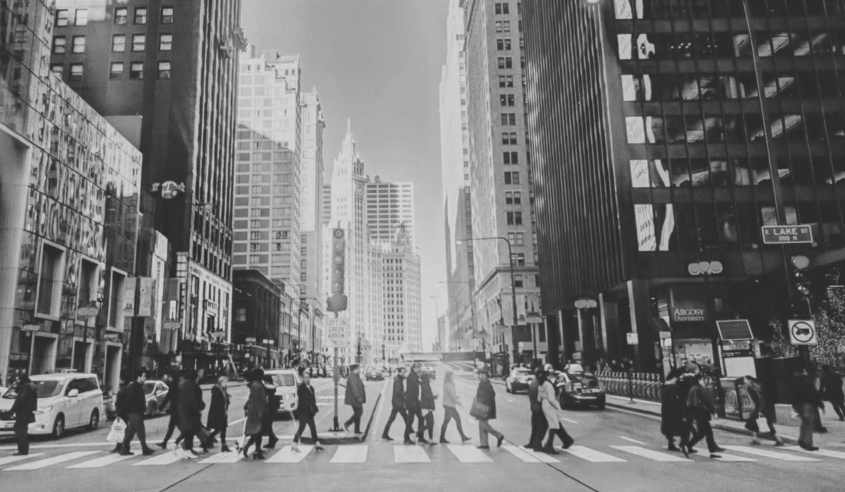 |  |  |  |  |  | Mirjam Nilsson  The scoop of the day  The latest updates  Themes and styles also help keep your document co-ordinated. When you click Design and choose a new Theme, the pictures, charts, and SmartArt graphics change to match your new theme. When you apply styles, your headings change to match the new theme.  Save time in Word with new buttons that show up where you need them. To change the way a picture fits in your document, click it and a button for layout options appears next to it. When you work on a table, click where you want to add a row or a column, and then click the plus sign. Reading is easier, too, in the new Reading view. You can collapse parts of the document and focus on the text you want.  When you work on a table, click where you want to add a row or a column, and then click the plus sign.  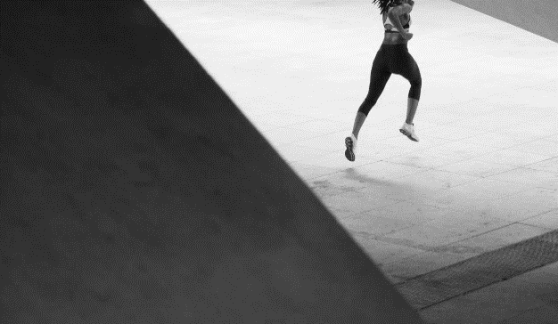
Picture Caption: To make your document look professionally produced, Word provides header, footer, cover page, and text box designs that complement each other.
Mirjam Nilsson

The latest breaking news
The latest updates to get you through the day
Save time in Word with new buttons that show up where you need them. To change the way a picture fits in your document, click it and a button for layout options appears next to it.  When you work on a table, click where you want to add a row or a column, and then click the plus sign.  Video provides a powerful way to help you prove your point. When you click |  | Online Video, you can paste in the embed code for the video you want to add. You can also type a keyword to search online for the video that best fits your document.  Themes and styles also help keep your document co-ordinated. When you click Design and choose a new Theme, the pictures, charts, and SmartArt graphics change to match your new theme.
 |  |  |  |  |  | Picture Caption: To make your document look professionally produced, Word provides header, footer, cover page, and text box designs that complement each other.
 |  |  |  | Page 2

May 2022 | The Dark Times |  |  |  |  |  | Enjoy then destroy
Mirjam Nilsson  The scoop of the day  The latest updates |  | To change the way a picture fits in your document, click it and a button for layout options appears next to it.  Themes and styles also help keep your document co-ordinated. When you click Design and choose a new Theme, the pictures, charts, and SmartArt graphics change to match your new theme. When you apply styles, your headings change to match the new theme.  Save time in Word with new buttons that show up where you need them. To change the way a picture fits in your document, click it and a button for layout options appears next to it.  When you work on a table, click where you want to add a row or a column, and then click the plus sign. Reading is easier, too, in the new Reading view. You can collapse parts of the document and focus on the text you want.  To change the way a picture fits in your document, click it and a button for layout options appears next to it. |  |  |  | Mirjam Nilsson  The scoop of the day  The latest updates  Themes and styles also help keep your document co-ordinated. When you click Design and choose a new Theme, the pictures, charts, and SmartArt graphics change to match your new theme. When you apply styles, your headings change to match the new theme.  To change the way a picture fits in your document, click it and a button for layout options appears next to it.  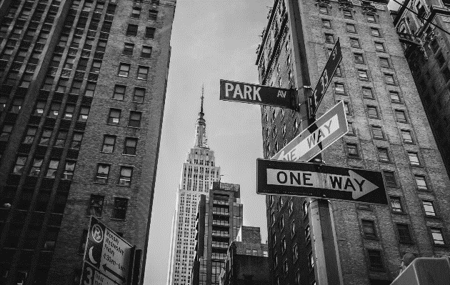
Picture Caption: To make your document look professionally produced, Word provides header, footer, cover page, and text box designs that complement each other.
To make your document look professionally produced, Word provides header, footer, cover page, and text box designs that complement each other. For example, you can add a matching cover page, header, and sidebar.
Click Insert and then choose the elements you want from the different galleries. Save time in Word with new buttons that show up where you need them.

 |  |  |  |  |  | Picture Caption: To make your document look professionally produced, Word provides header, footer, cover page, and text box designs that complement each other.
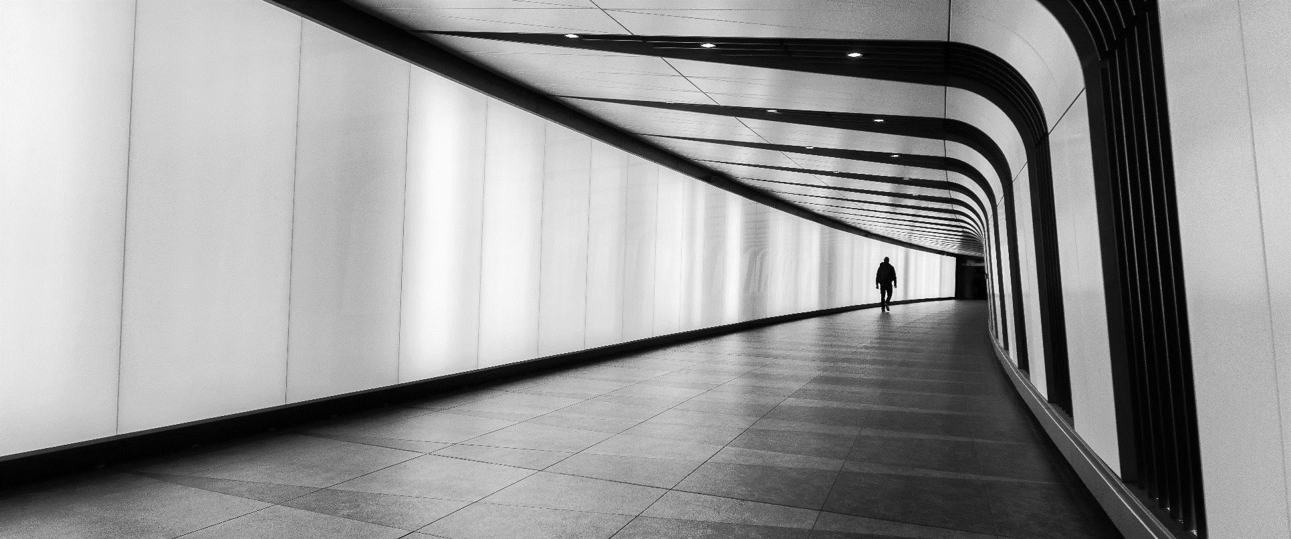
Picture Caption: To make your document look professionally produced, Word provides header, footer, cover page, and text box designs that complement each other.
Mirjam Nilsson

The latest breaking news of the day
The latest updates to get you through the day
To make your document look professionally produced, Word provides header, footer, cover page, and text box designs that complement each other. For example, you can add a matching cover page, header, and sidebar. Click Insert and then choose the elements you want from the different galleries.  Save time in Word with new buttons that show up where you need them. To change the way a picture fits in your document, click it and a button for layout options appears next to it. Themes and styles also help keep your document co-ordinated. When you click Design and choose a new Theme, the pictures, |  |  |  | charts, and SmartArt graphics change to match your new theme. When you apply styles, your headings change to match the new theme.  Save time in Word with new buttons that show up where you need them. To change the way a picture fits in your document, click it and a button for layout options appears next to it. When you work on a table, click where you want to add a row or a column, and then click the plus sign. Reading is easier, too, in the new Reading view. You can collapse parts of the document and focus on the text you want.
 |  |  | Page 3

May 2022 |  | Out of Character |  |  |  |  |  | Enjoy then Destroy
Storyteller Announcments
Picture Caption: To make your document look professionally produced, Word provides header, footer, cover page, and text box designs that complement each other.
The World As You Know It
Rumours & General Knowledge
General Knowledge | Many of the courts are adjusting to the changes in regulations and masquerades are being up held with tighter measures than ever.  Everyone feels a quiet consistent discomfort. Rumours from London are the city is on edge as rage takes hold and kindred frenzy far easier than normal. |  |  |  | Save time in Word with new buttons that show up where you need them. To change the way a picture fits in your document, click it and a button for layout options appears next to it. When you work on a table, click where you want to add a row or a column, and then click the plus sign. Reading is easier, too, in the new Reading view. You can collapse parts of the document and focus on the text you want.
The Ventrue are shaken by recent accusations and in fighting.  The Toreador are watching Glasgow closely as the Toreador elder Hugh Jackson and Mary raise the standards.  The Malkavians are fairly quiet and occupied with Soterian upkeep  No tremere rumours  The Brujah approval of Prince Esteban is high  The Nos have their eyes on Glasgow as the clan influence grows  The Gangrel are deeply unhappy that the Ravnos have been given free reign to travel the courts of the UK. |  |  |  |  | Big Rumour in UK  - Mirjam Nilsson
Video provides a powerful way to help you prove your point. When you click Online Video, you can paste in the embed code for the video you want to add. You can also type a keyword to search online for the video that best fits your document. To make your document look professionally produced, Word provides header, footer, cover page, and text box designs that complement each other. For example, you can add a matching cover page, header, and sidebar.
Click Insert and then choose the elements you want from the different galleries. Themes and styles also help keep your document co-ordinated. When you click Design and choose a new Theme, the pictures, charts, and SmartArt graphics change to match your new theme.

 |  |  |  | Page 4

